**Object Oriented Programming Laboratory Exercise**

**Session 10 Date:10/12/2020**

**Method overriding, Abstract class and Interfaces in Java.**

**_________________________________________________________________**

**1. Write a program to implement the following using abstract classes.**

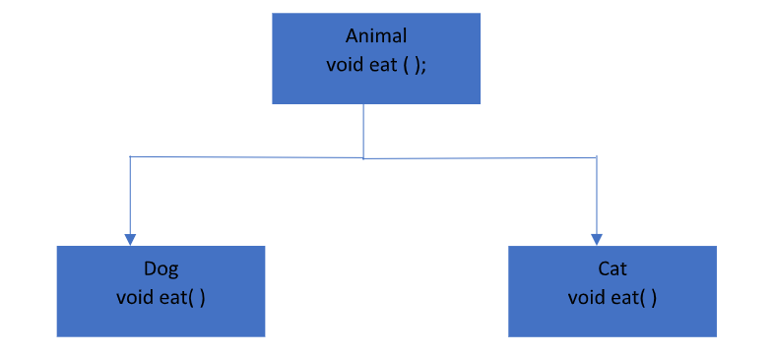

abstract class Animal1

{

abstract void eat();

}

class Dog extends Animal1

{

void eat()

{

System.out.println("Dog is eating");

}

}

class Cat extends Animal1

{

void eat()

{

System.out.println("Cat is eating");

}

}

class Animal

{

public static void main(String args[ ])

{

Dog D1 = new Dog();

D1.eat();

Cat C1 = new Cat();

C1.eat();

}

}

OUTPUT

Dog is eating

Cat is eating

**2. Write a program to implement method overriding with your own example.**

class animal1

{

public void eat()

{

System.out.println("Human is eating");

}

}

class Boy extends animal1

{

public void eat()

{

System.out.println("Boy is eating");

}

}

class Overriding

{

public static void main( String args[])

{

Boy obj = new Boy();

obj.eat();

}

}

**OUTPUT**

**Boy is eating**

**3. Write a program to implement multiple inheritance in java using Interfaces.**

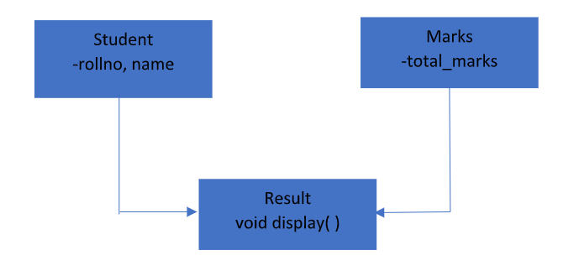

**class Interface**

**{**

**public static void main(String args[])**

**{**

**Display1 D1 = new Display1();**

**D1.Studinfo(19,"Siddhi kinlekar");**

**D1.Displayall();**

**Display2 D2 = new Display2();**

**D2.Marksinfo(499);**

**D2.Displayall();**

**}**

**}**

**interface Result**

**{**

**public void Displayall();**

**}**

**class Student**

**{**

**int rollno;**

**String name;**

**public void Studinfo(int rn,String n)**

**{**

**rollno = rn;**

**name = n;**

**}**

**}**

**class Marks**

**{**

**int total_marks;**

**public void Marksinfo(int tm)**

**{**

**total_marks = tm;**

**}**

**}**

**class Display1 extends Student implements Result**

**{**

**public void Displayall()**

**{**

**System.out.println("Student Name :"+name);**

**System.out.println("Student RollNo :"+rollno);**

**}**

**}**

**class Display2 extends Marks implements Result**

**{**

**public void Displayall()**

**{**

**System.out.println("Total Marks:"+total_marks);**

**}**

**}**

**OUTPUT**

**Student Name :Siddhi kinlekar**

**Student RollNo :19**

**Total Marks:499**